

**CNG WEB PORTAL**

**CNG Stock Movement and LCV Scheduling Dashboard  
Link for the Portal:** [**Click Here**](http://182.77.57.154/CNGPortal/staging/html/login.php)

Technologies used:

* HTML
* CSS
* JavaScript
* PHP
* MySQL

The portal contains following Modules:

1. Registration & Admin
2. Master tab
3. Tracking of LCV
4. Analytical Report
5. Gas Reconciliation
6. Scheduling

**Login Window**

Login with your name as username and mobile number as password.

Only manager and admin a have access to the portal.

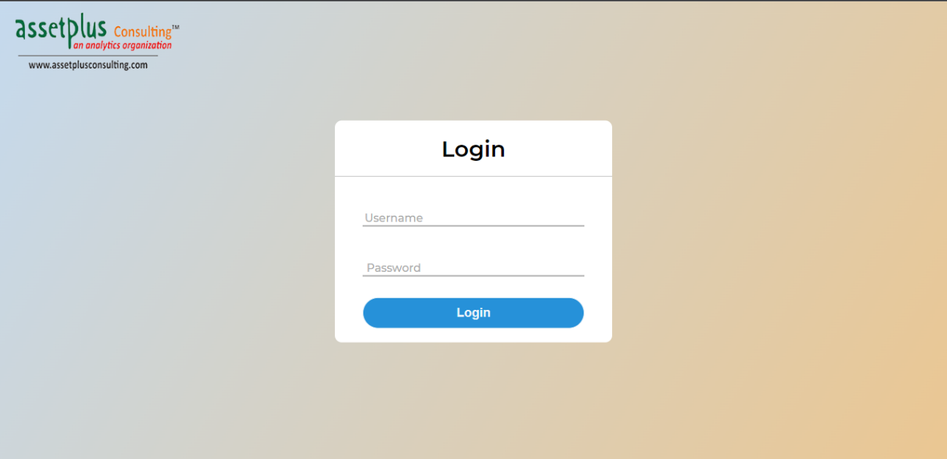

**Dashboard:**

Details about LCVs, Gas status at DBS and LCV route shown in tabular form (Source and Destination) with live location on map.

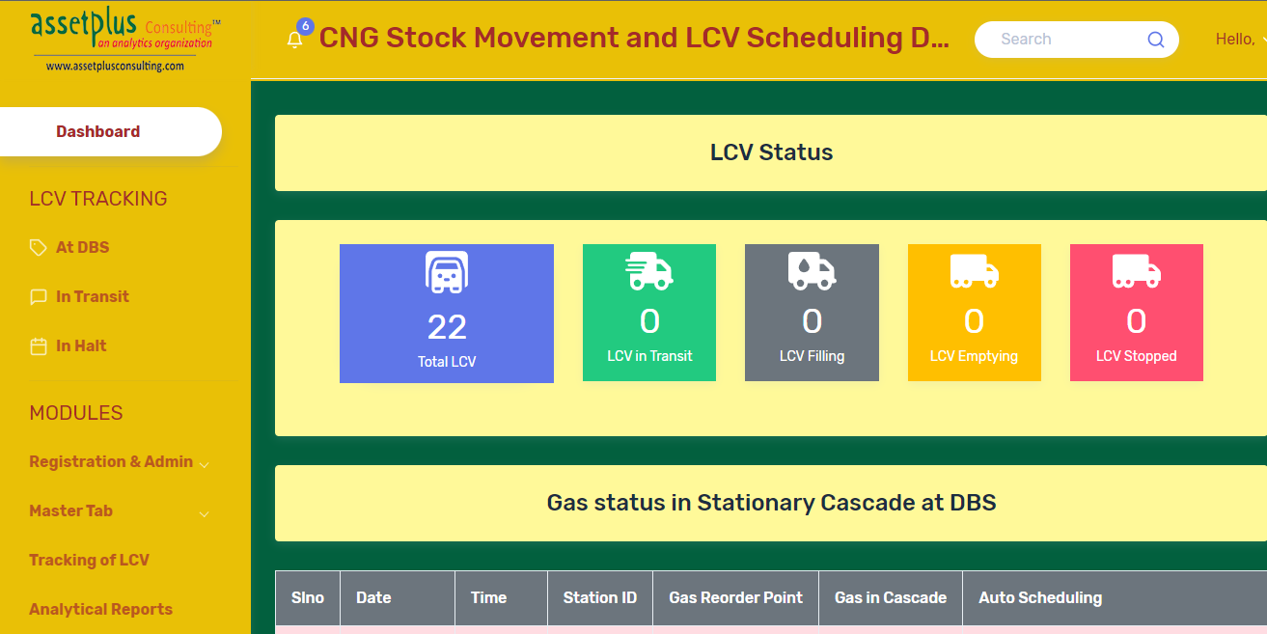

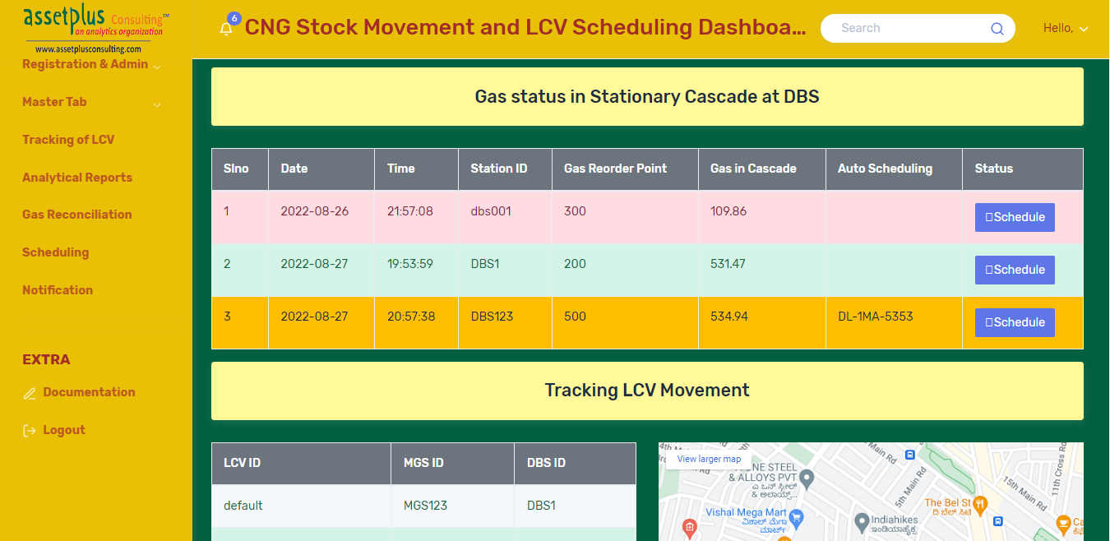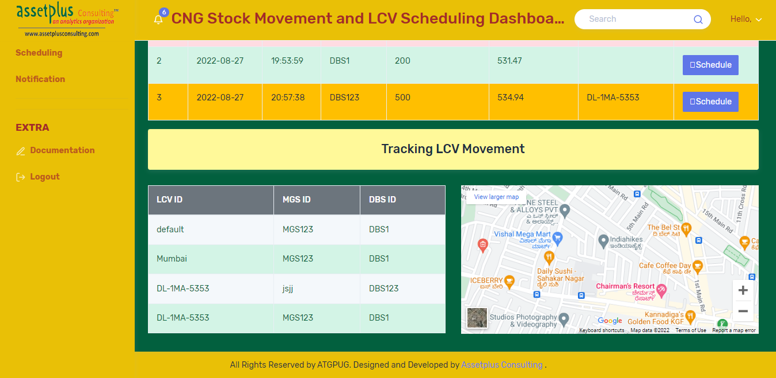

**Registration & Admin:**

* **Registration:**

Register Organization and Employee with required details.

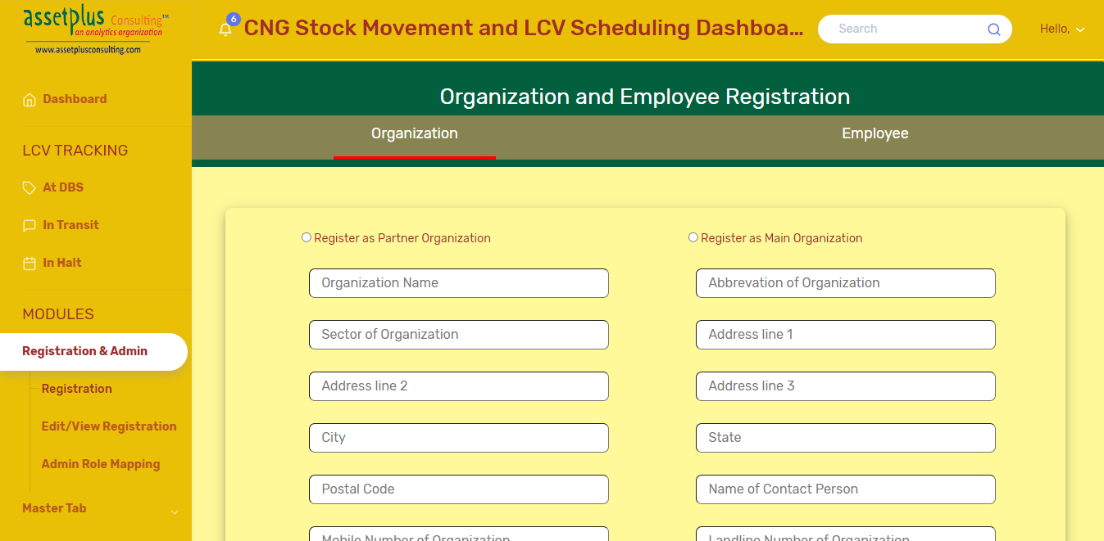

* **Edit/View Registration**:

Edit, Update or view details of organization and employee in this tab.

Details can be assessed using mobile number of respective organization and employee.

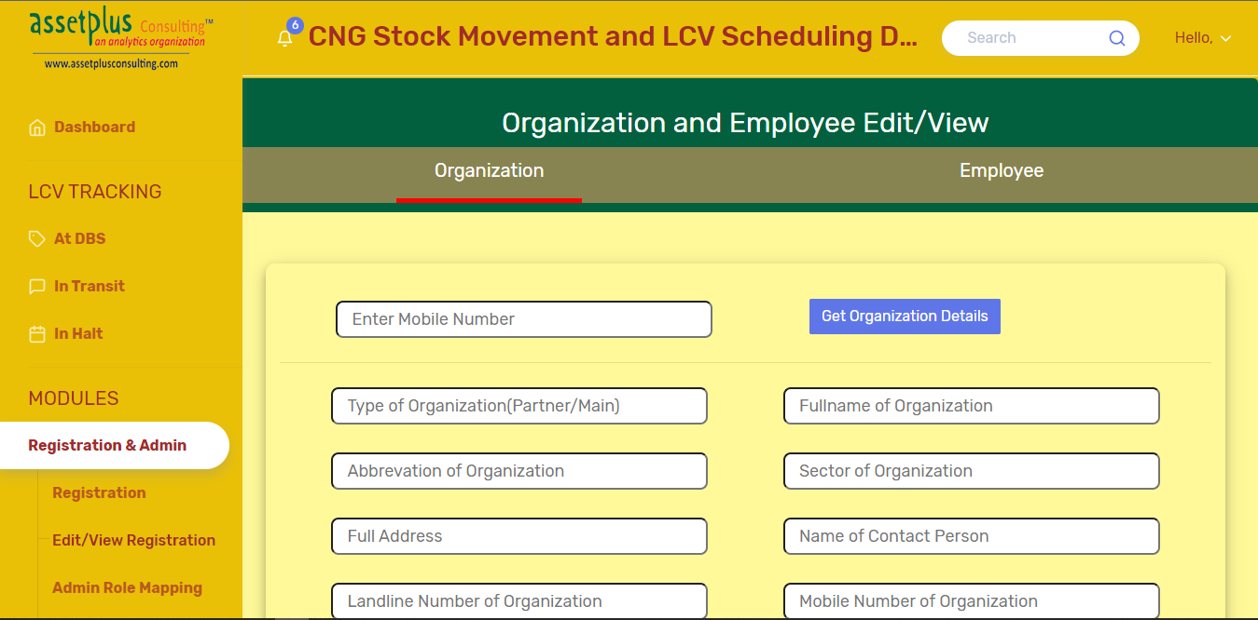

* **Registration & Admin:**

Assigning each employee their role(Operator, Manager or Admin).

Only manager is assigned notification approver MGS/BDS. Operator and admin will not be assigned any notification approver MGS/DBS.

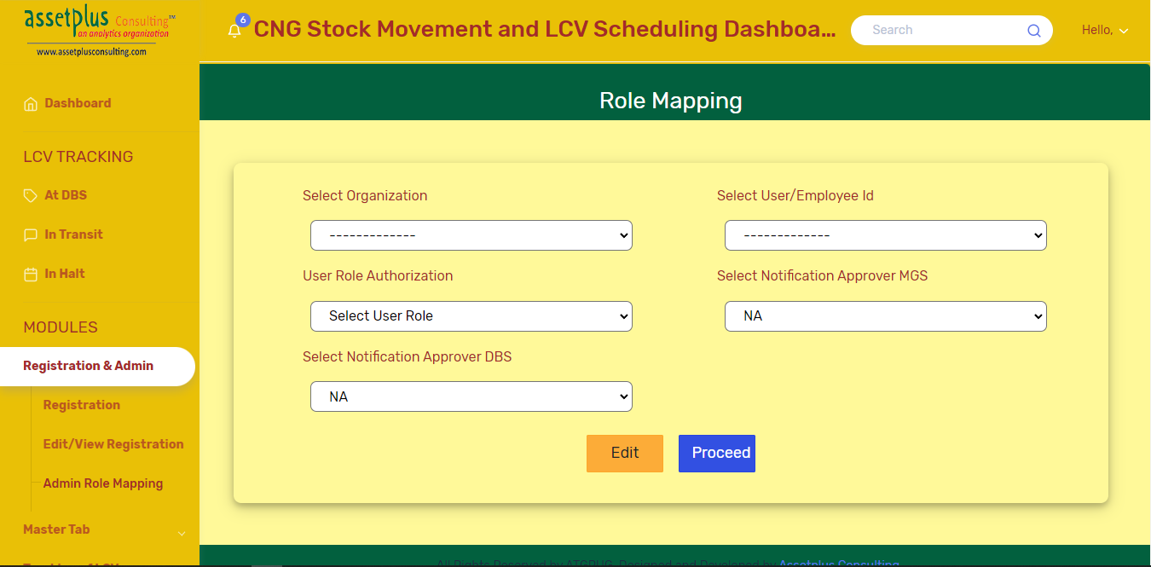

**Master Tab:**

* **CNG/MGS/DBS:**

1. **Register Station:** Register Station with required details.

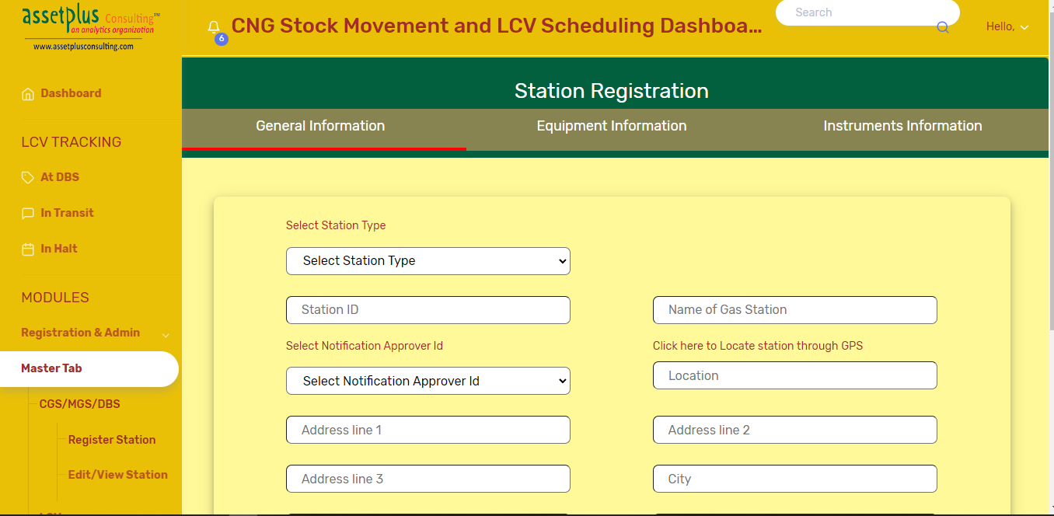

1. **Edit/View Station:** Edit, Update or view details of Station in this tab. Details can be assessed by selecting station type and then respective station id.

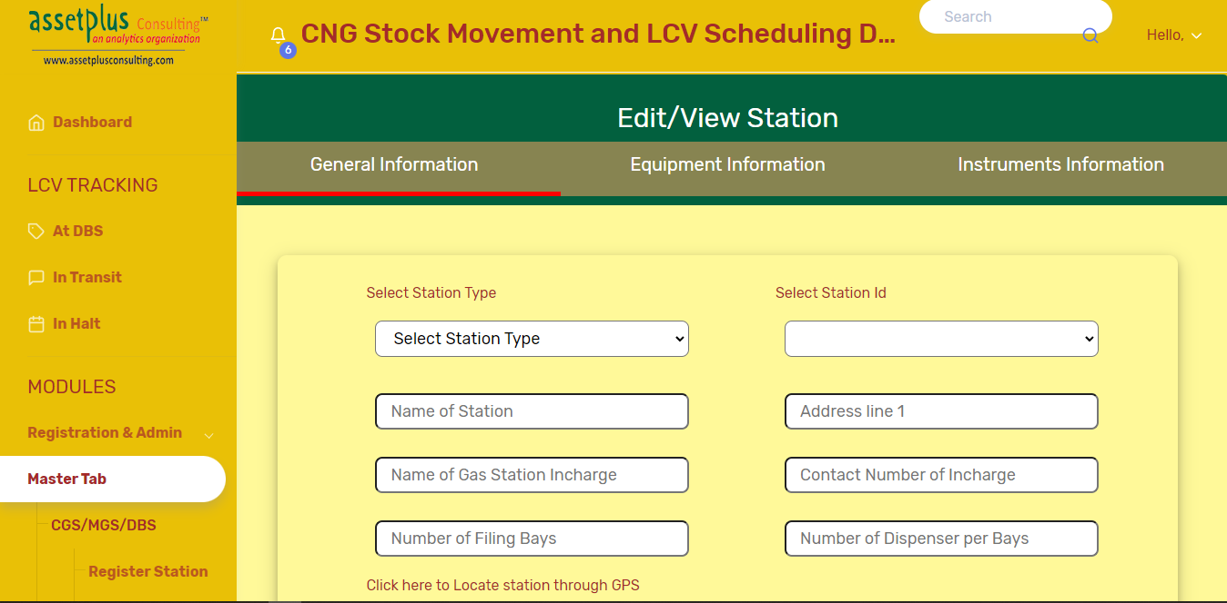

* **LCV:**

1. **Register LCV:** Register LCV with the required details.

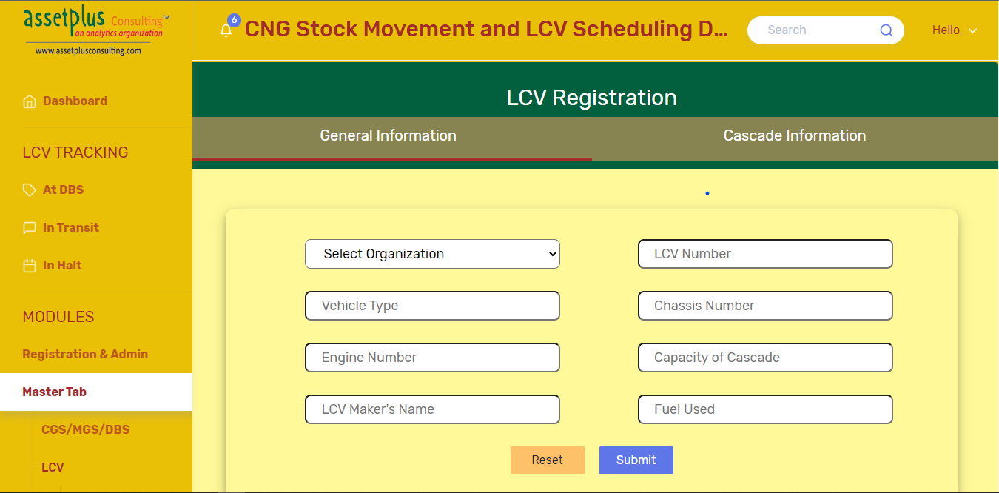

1. **Edit/View LCV:** Edit, Update or view details of Station in this tab. Details can be assessed by selecting station type and then respective station id.

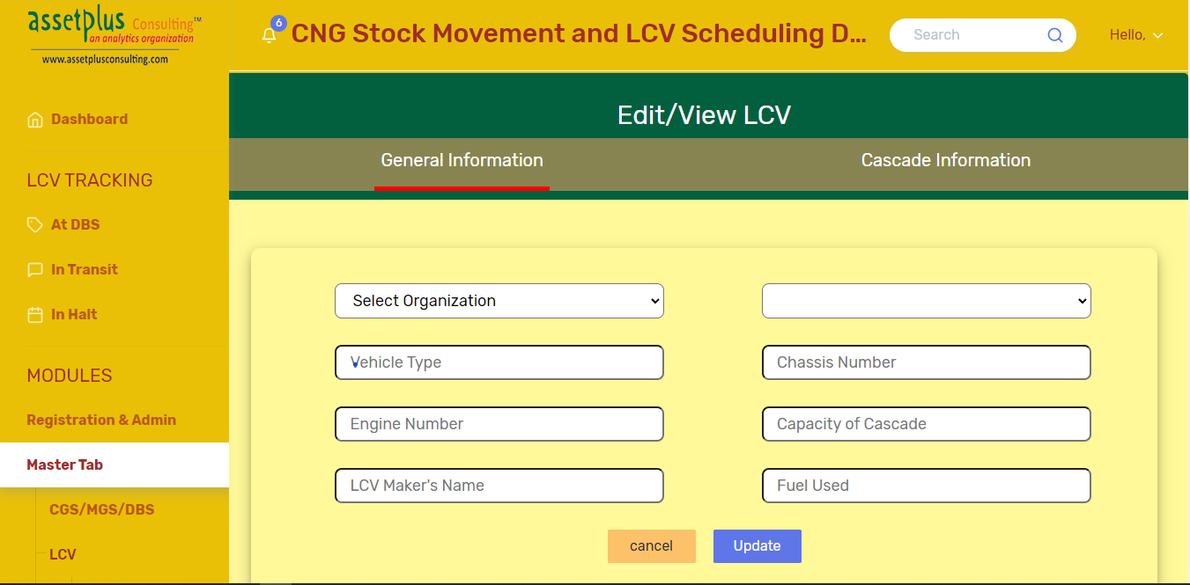

1. **Allocate LCV to MGS:** Allocate LCV to MGS. Already allocated LCV list is shown at bottom of the page. A MGS can have more than one LCVs but a LCV can be allocated to only one MGS. If a LCV is already allocated to MGS then MGS can be updated by simply following the steps of allocation. LCV will be allocated to the last MGS select.

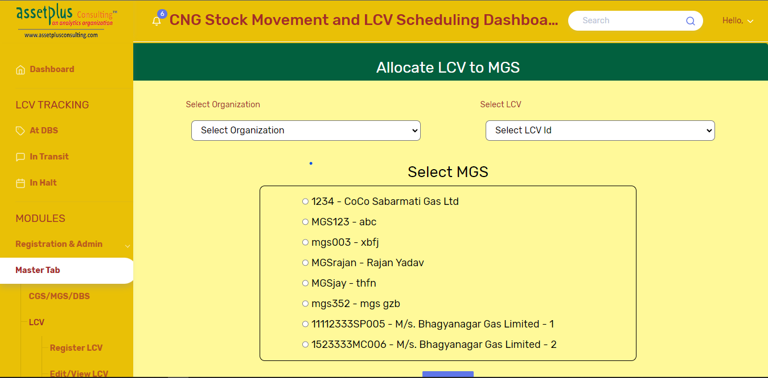

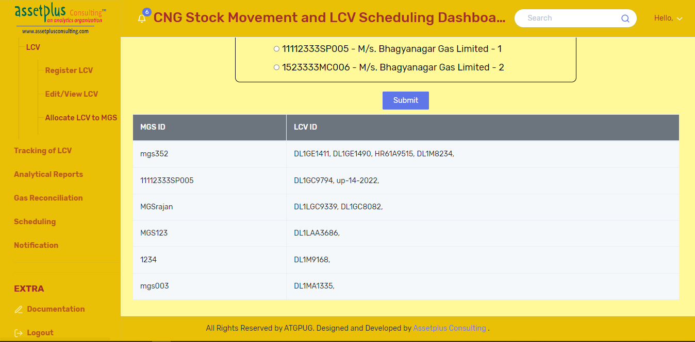

**Analytical Reports:**

* **Notification:** It have report about notification approval lag. Report can be downloaded as excel file.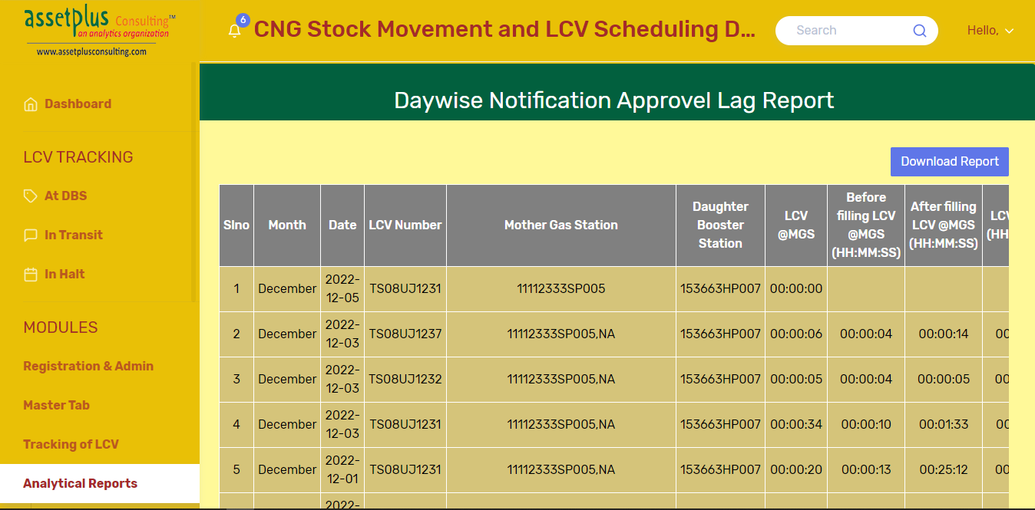
* **Vehicle Turnaround Time:** 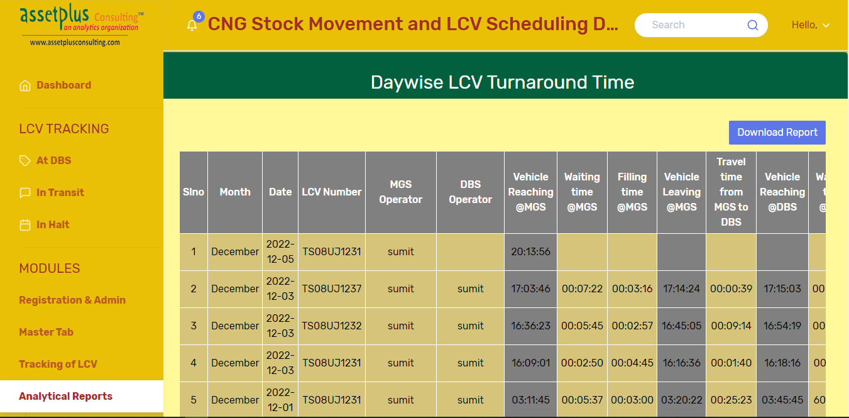
* **Total gas loss between stations:**

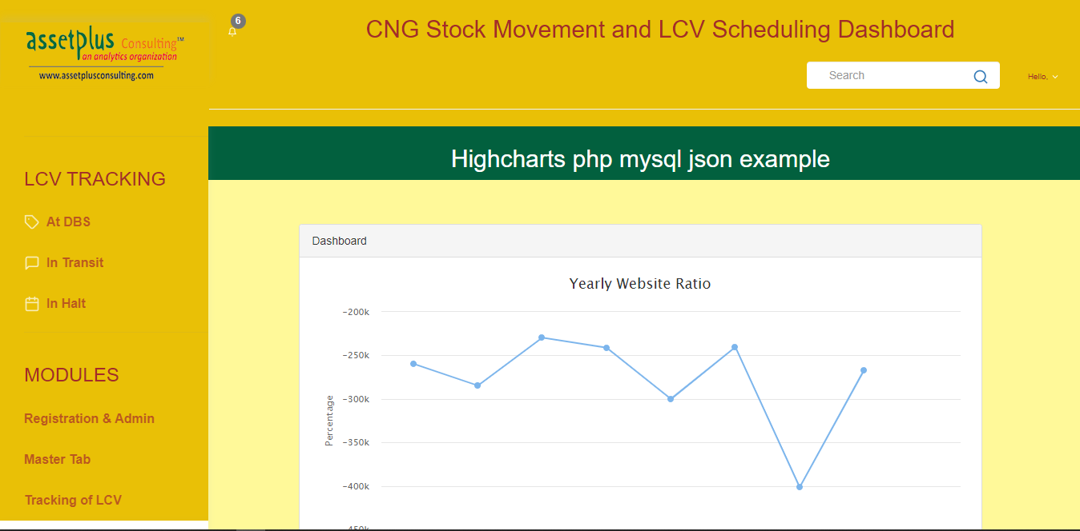

**Gas Reconciliation:**

* **Organization Level:**

1. **Cascade Report:**

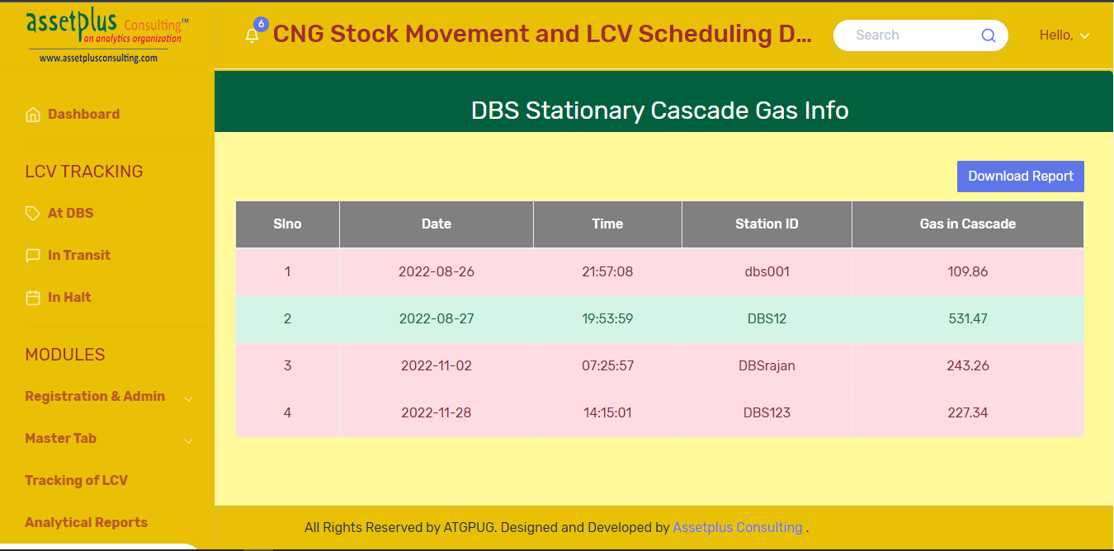

1. **Summary Report:**

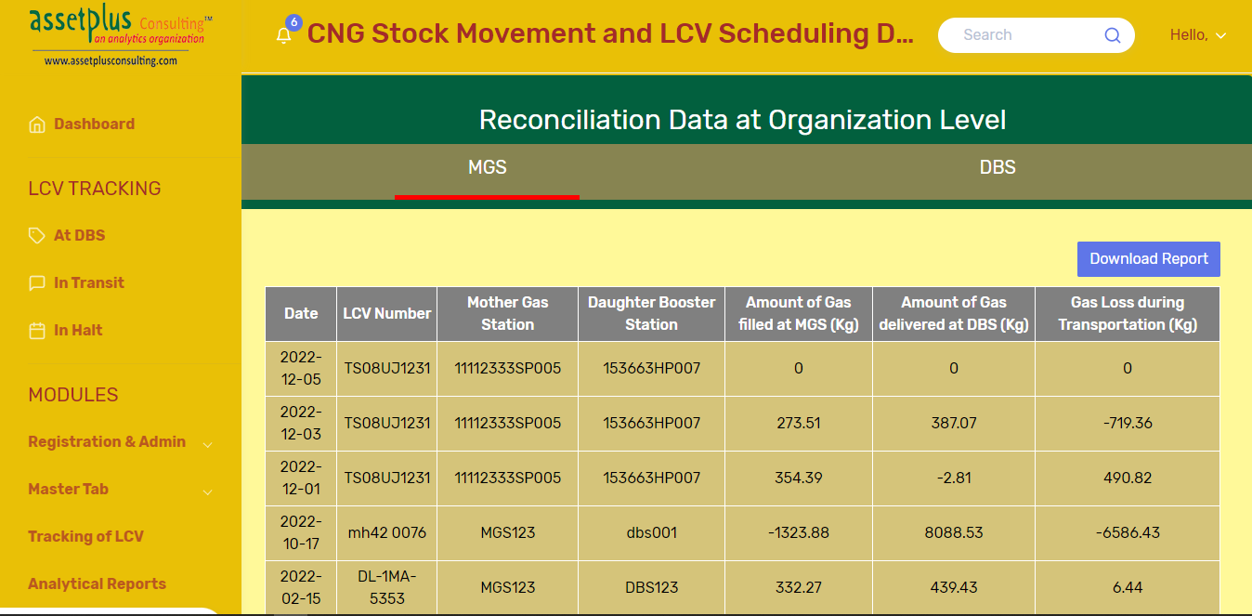

* **MGS Level:**

1. **Detailed Report:**

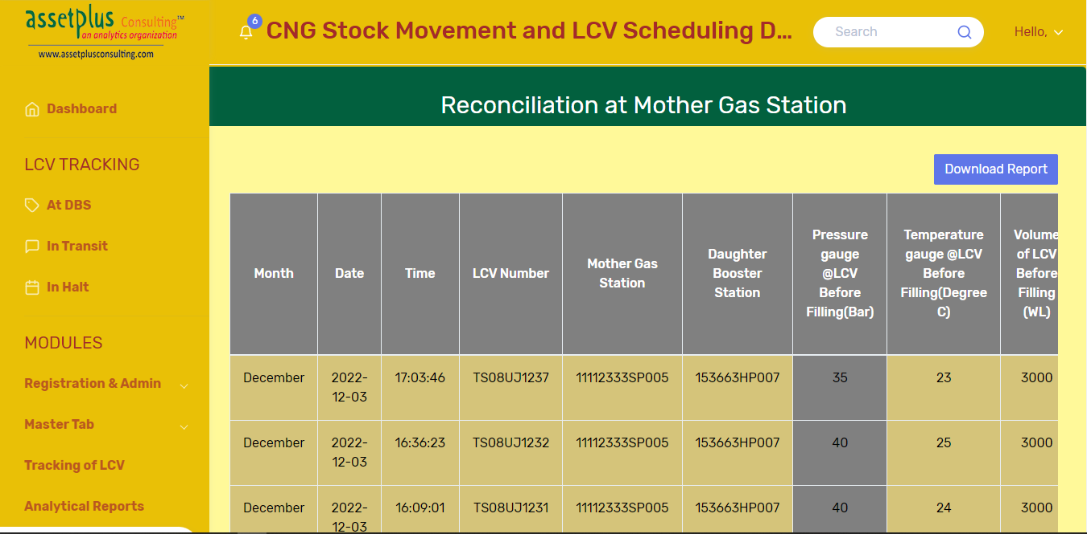

1. **Summary Report:**

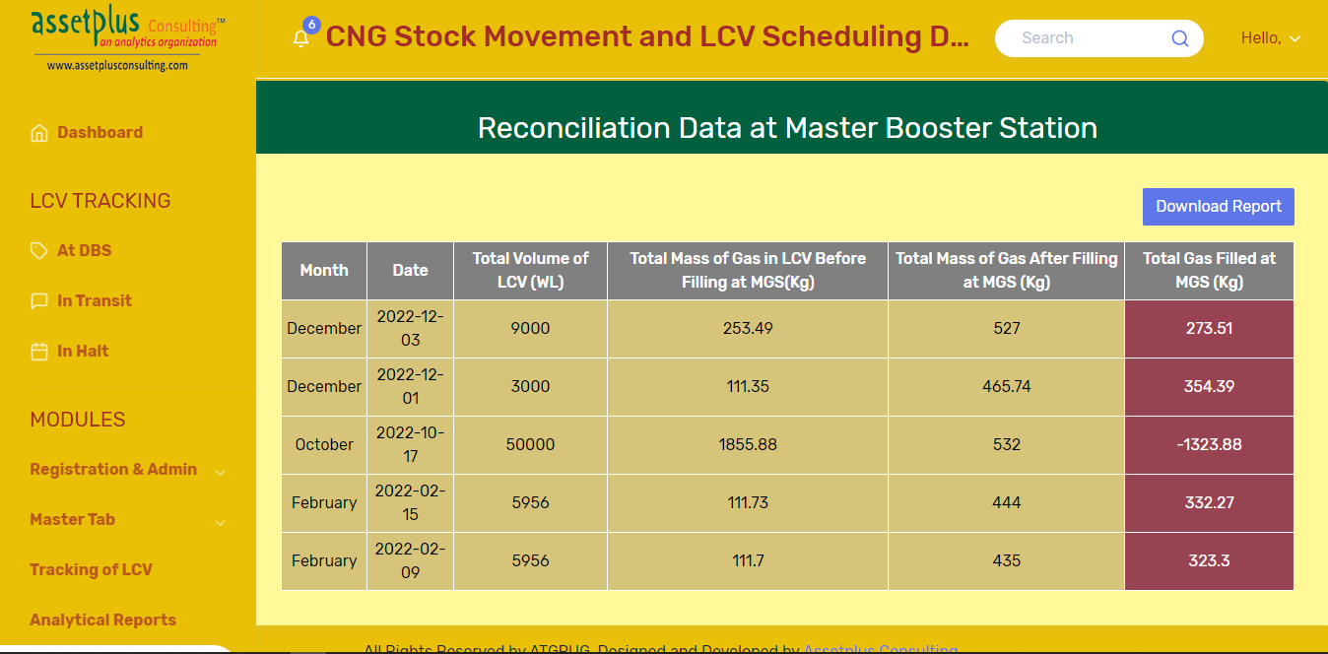

* **DBS Level:**

1. **Detailed Report:**

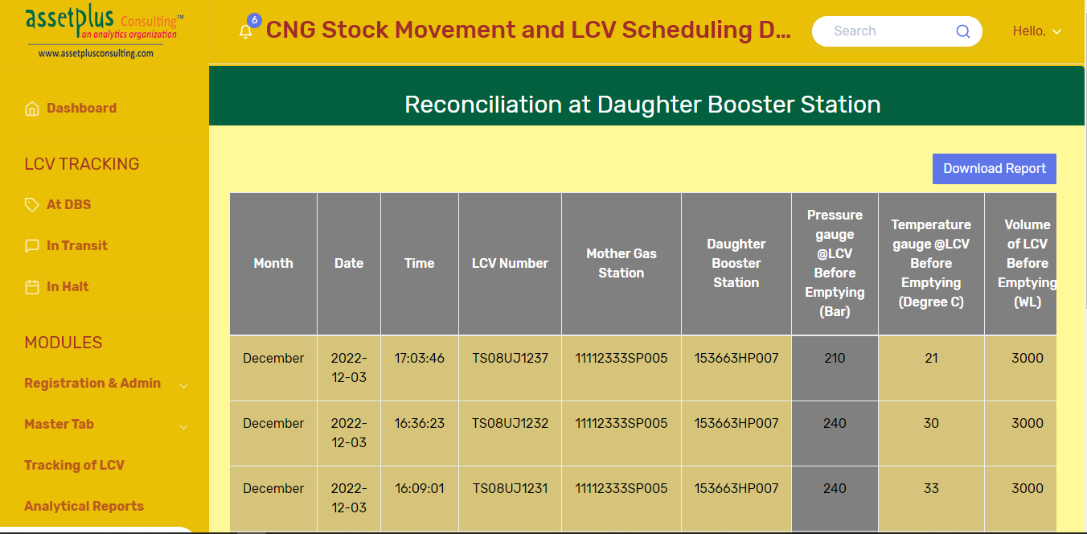

1. **Summary Report:**

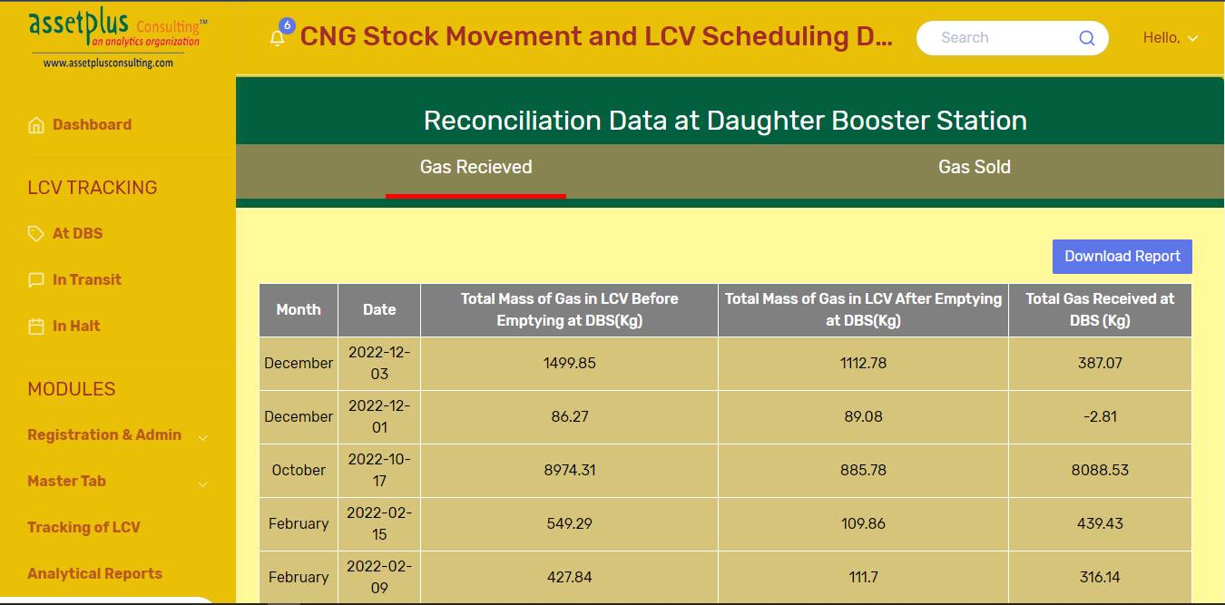

* **Transportation Level:**

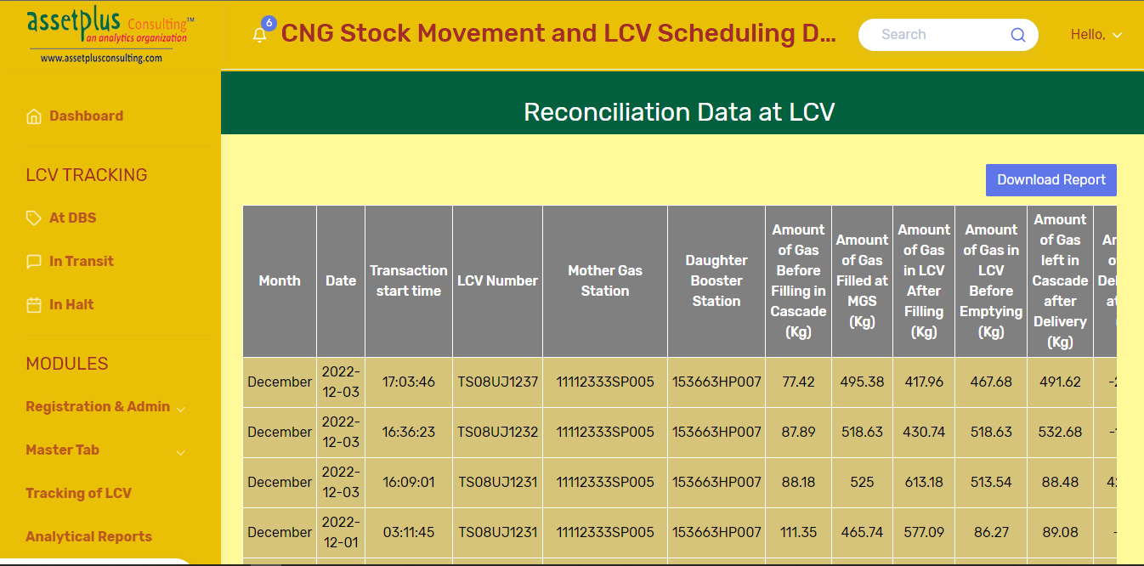

**Scheduling:**

Scheduling from MGS to its DBS, calculate distance and approximate time to reach the destination. Also LCVs’ and stations are marked on the map.

Can re-route already scheduled LCV in case of urgency.

